## Crowdfunding Report

* Given the provided data, what are three conclusions that we can draw about crowdfunding campaigns?

1. Crowdfunding campaigns tend to be most successful in the early Summer (June & July), but have a steep drop-off in success rate once August hits.
2. Theater projects (all of which were Plays) have by far the most crowdfunding requests, while Journalism projects have the least.
3. For the majority of categories and subcategories, crowdfunding projects had a slightly higher than 50% chance of being funded. Some outliers had even greater chances, such as Technology and Film and Video.

* What are some limitations of this dataset?
  + We do not know what type of incentives were offered as part of the crowdfunding requests. Incentives (such as early access, customizations, etc.) could skew some projects to success more than others.
  + A lot of the data is fairly dated.
  + Trends and current events can play a role in the interest level of specific projects/categories (e.g. the type of projects that were successfully funded during Covid might look a lot different than not).
  + No data on demographics of backers which could be particularly important
  + The donation contributions need to be normalized to a single currency so that we are comparing apples-to-apples.
* What are some other possible tables and/or graphs that we could create, and what additional value would they provide?
  + Step 1, and as stated above, is to add a new column to normalize currency to rebuild the Donation column and then re-run the previously done analysis using this. I would convert everything to USD using conversion rates found online for simplicities sake.
  + I would create a new column to bucket Average Donation in ranges ($0 - $10, $10 - $25, $25 - $50, $50 - $100, $100+) and then create a new pivot table (row: category; columns and values: average donation bucket). This would let me get insight into if some categories regularly drive larger contributions in a way that’s easier to consume. An example of this:
    - 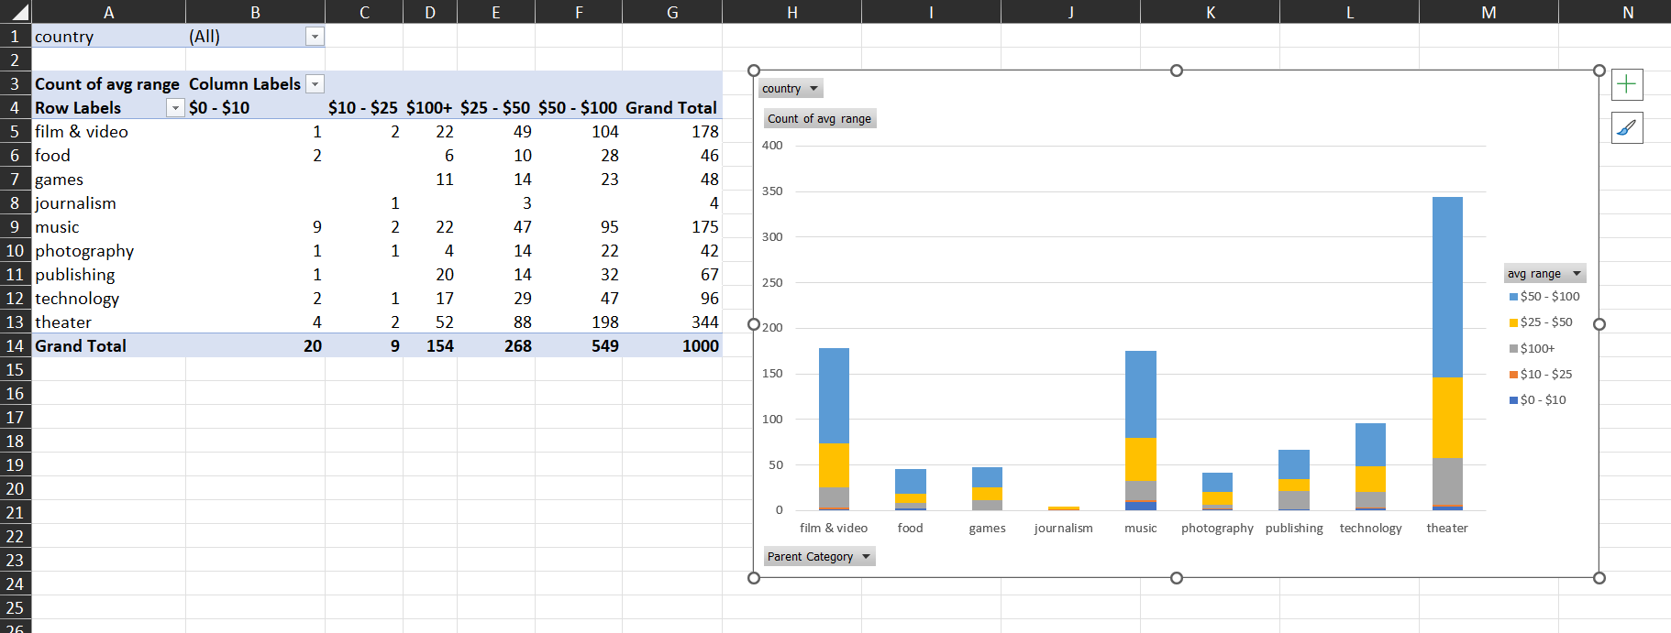
  + Similarly, average donation over time to see if some months drive larger contributions. Compare this against number of backers over that same timeline. The goal here is to see if more people on average are donating in more successful months, vs. less backers giving more money. An example of this – where it’s worth noting that while less total people contribute in October on average, the average donation actually increases!
    - 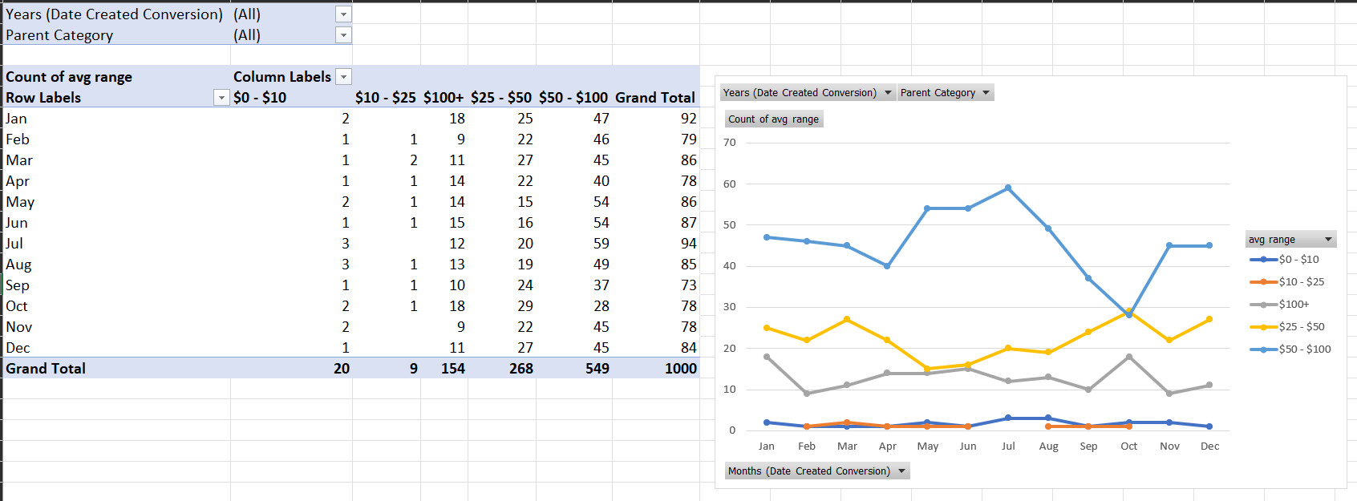
  + Average length of a campaign per category against outcome, so we can target how long the ideal campaign lasts.

*Please note that my Statistical Analysis answers are in a textbox inside the Excel workbook (Sheet10).